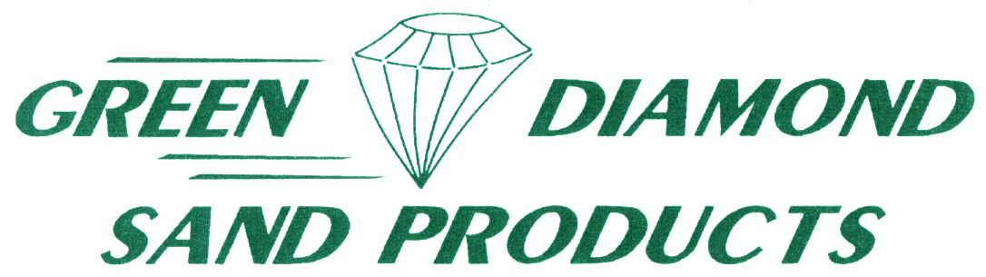

ABRASIVE  ROOFING  FOUNDRY SANDS  FILLERS  CONSTRUCTION

CONVERTING TO GREEN DIAMOND SAND
FREQUENTLY ASKED QUESTIONS

- Will you run out of sand? For all practical purposes, NO. If we double our current production rates, and Foundry sand is the lesser of our three main product lines, there is over 50 years of reserves. None of us have to worry about running out.

- Do I need to throw out my current sand? The simple answer is NO. You can take out ¼ or 1/3 of your system and replace it with premulled Green Diamond sand, which will accelerate the conversion. Or, you can just stop putting in Olivine and start putting in Green Diamond sand. Actually, Green Diamond sand is Olivine (Magnesium Ortho Silicate), and it is compatible with the natural Olivine. You will not see any difference in your system sand until you get to about 50% Green Diamond sand. At that point, you should start seeing an increase in Permeability and you should be able to start reducing your pouring temperature. You can also start reducing the makeup sand as the insulating properties of Green Diamond sand reduce the clay burnout and there is less contamination to dilute with new sand.

What grade of Green Diamond sand should I use? We have the equivalent grade that compares with the Olivines (refer to the Green Diamond/Olivine Comparison brochure). We have an 85, 100, 115, 130, and 145 AFS sands. We prefer that you send in a sand sample to be tested so we can accurately recommend the proper grade to use. In general, the AFS 100 is used by shops that pour only Aluminum and have automatic molding machines. The AFS 115 is used by shops that have squeezers, etc. and perhaps they pour some Brass. The AFS 130 is used for belt buckles and plaques. The AFS 145 is the next step finer. We have seen very little difference, if any, between the AFS 130 and the AFS 145. Proper sand control has 10 times the difference compared to the difference between AFS 130 and AFS 145, and they are all the same price. A number of you currently use le 170 or blend le 170 with other grades. We think you should try the AFS 130 and/or AFS 145 to see if it is a good fit. If there is enough demand, we could produce a finer grade.

- Is Green Diamond Sand more expensive? The delivered price of Green Diamond Sand is very dependent on freight, etc. Even if it is a little more expensive, and it probably won’t be, you should see savings in reduced
makeup sand, lower pouring temperatures, and better finish, which should

CONVERTING TO GREEN DIAMOND SAND
(page 2)

negate any higher price. Also, since Green Diamond Sand is 10-20% lighter
in bulk density, there would be a savings in disposal as you pay by the ton and there are more cubic feet of Green Diamond Sand per ton than Olivine.

- Does Green Diamond Sand reclaim well? The simple answer is YES. We have documentation that shows that the makeup sand, for dry reclaimed Sodium Silicate no-bake, was reduced from 35% with Olivine to 15% with Green Diamond Sand. The Green Diamond Sand reclaims faster, easier, and is cleaner than the natural Olivine, and doesn’t break down as easily as the natural Olivine.

- What clay (s) should I use with Green Diamond Sand? There is no need to change your clay (s). You can use the same mix as you were using with Olivine. If you would be using Green Diamond Sand for facing, you might want to tweak the clay (s) up a little because of the bulk density difference. There is more surface area per lb. of sand.

- Can I use Green Diamond Sand for cores? YES. Green Diamond Sand will work with the same binders that Olivine will. Again, you might have to tweak the binder level up a little because of the greater surface area, but you should find that there is about the same amount of binder per core, or cubic foot. If you are running a continuous mixer with Olivine, you can replace the Olivine with Green Diamond sand and you probably won’t have to make much, if any, changes to the binder level. We have several customers using our 50X140 grade (65 AFS) for cores and no-bake molds.

- Do I have to change my gating and risering? The short answer is NO. If you have a job that is border line risered, you may have to increase the riser slightly as the slower solidification could allow the casting to feed better.

We will be more than happy to help you convert to Green Diamond Sand. We will gladly run sand tests, at no charge, to use to monitor your sand system. We have many, many years of experience working with not only Olivine sand, but Green Diamond sand, as well, and we can easily advise you on any changes that should be made to your sand during and after your conversion.

